**IDEATION PHASE – DOCUMENT 1: BRAINSTORMING**

|  |  |
| --- | --- |
| **Date** | 06 November 2025 |
| **Team ID** | NM2025TMID06934 |
| **Project Name** | Lease Management |
| **Maximum Marks** | 4 Marks |

**Title: Brainstorming for “Lease Management”**

**BRAINSTORMING**

**1. Objective**

The purpose of this brainstorming phase is to explore and evaluate multiple ideas to solve the challenges in traditional lease handling such as document mismanagement, payment delays, and lack of transparency. The goal is to identify a feasible technical solution — using Salesforce — to automate, track, and secure the leasing process between tenants and property owners.

**2. Brainstorming Process**

**The brainstorming was conducted in three structured rounds:**

|  |  |
| --- | --- |
| **Round** | **Focus Area** |
| Ideation Round 1 | Listing all possible problems in lease handling and possible digital solutions |
| Ideation Round 2 | Shortlisting ideas based on feasibility, scalability, and user needs |
| Ideation Round 3 | Converting filtered ideas into Salesforce-based system workflows |

**Tools used: Miro, Notepad, Jam board, and team discussion calls.**

**3. Stakeholders Involved**

|  |  |  |
| --- | --- | --- |
| **Stakeholder** | **Role in Brainstorming** | **Contribution** |
| Property Owners | Shared real-life problems in managing multiple tenants | Explained rent follow-up, lease expiry issues |
| Tenants | Shared user experience issues | Reported lack of payment reminders & communication gaps |
| Real Estate Agents | Provided market workflow insights | Suggested features like document verification & renewal alerts |
| Technical Mentors | Guided Feasibility & Platform Selection | Ensured the idea fits Salesforce ecosystem |

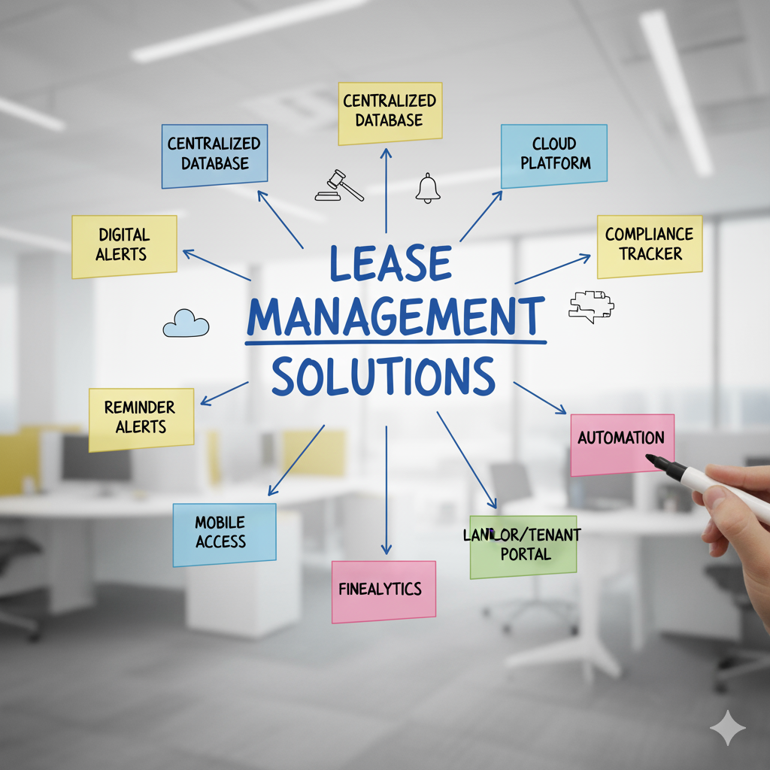

**4. Idea Generation Methods**

|  |  |
| --- | --- |
| **Method** | **Purpose** |
| Mind Mapping | Mapped flow from Property → Lease → Tenant → Payment → Renewal |
| SCAMPER | Modified traditional lease process with automation & dashboards |
| Reverse Brainstorming | Asked: "Why do lease agreements fail?" to expose root issues (late rent, lost papers, no reminders) |

**5. Consolidated Ideas**

|  |  |  |  |
| --- | --- | --- | --- |
| **Idea No** | **Idea Description** | **Feasibility** | **Impact** |
| 1 | Centralized lease document storage | High | High |
| 2 | Auto rent reminder & expiry alerts | Very High | Very High |
| 3 | Payment tracking dashboard | High | High |
| 4 | Tenant–Owner communication log | High | Medium |
| 5 | AI-based rent prediction | Low | Moderate |

**Final selected direction: Salesforce-based Automated Lease Tracking System**

**Why?**

* Available free dev org
* Easy automation with Flows
* Role-based access for Owner, Tenant & Admin
* Real-time dashboards and reports

**6. Rationale for Choosing Salesforce**

**Salesforce provides:**

* Custom Objects for Lease, Tenant, Property, Payments
* Automation using Flow, Email Alerts & Triggers
* Dashboards for overdue rent, upcoming renewals, tenant status
* Secure cloud platform with user role control

**7. Outcome of Brainstorming**

The finalized concept “Lease Management” is a cloud-based lease management solution that:

* Stores all lease contracts digitally
* Automates rent reminders & renewal alerts
* Tracks payments and communication
* Reduces disputes through transparent records

It is designed to replace manual lease handling with a structured, automated Salesforce solution.Top of Form

**IDEATION PHASE – DOCUMENT 2:**

**DEFINE PROBLEM STATEMENT**

**Title: Problem Definition for “Lease Management”**

**1. Objective**

The objective of this document is to define the key problem faced in traditional lease handling, its causes, impact, and the technical justification for building a digital lease management solution using Salesforce.  
The purpose is to convert an initial idea into a clearly structured problem statement that will guide the entire project lifecycle.

**2. Context and Background**

Lease agreements are commonly used across residential, commercial, and industrial sectors.  
However, the current process of managing leases is mostly **manual, paper-based, and prone to disputes**.

Common issues include:

* Missed rent payment reminders
* Lack of centralized record storage
* Difficulty in tracking lease expirations
* Legal disputes due to unclear terms
* No digital record of tenant-landlord communication

Studies show that **over 60% of property owners in India still use offline records and WhatsApp communication for managing tenants**.  
This results in errors, delayed payments, and lack of transparency between tenants, landlords, and property managers.

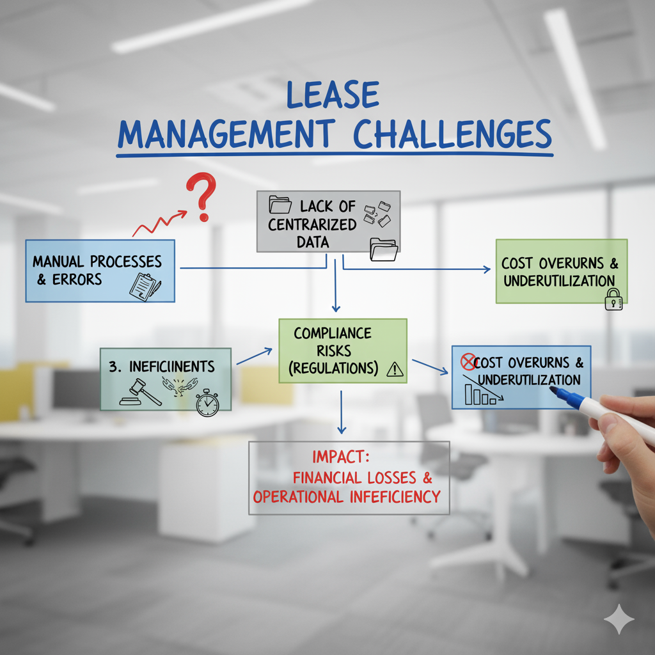

**3. Problem Observation**

Based on field interviews with property owners, tenants, and real estate agents, the following issues were identified:

|  |  |
| --- | --- |
| **Issue** | **Observation** |
| Manual Documentation | Lease contracts stored as physical papers or scattered PDFs |
| No Auto-Reminders | Payments and renewal alerts not automated |
| Lack of Transparency | Tenants and owners do not share a unified platform |
| Dispute Handling | No evidence-based record of communication & payments |
| Expiry & Renewal Chaos | Owners forget to renew leases on time, causing legal issues |

These issues indicate the need for a **centralized digital lease management system** that automates workflows and keeps all stakeholders connected.

**4. Core Problem Statement**

“There is no unified and automated digital platform to manage lease agreements, track payments, handle communication, and ensure timely renewals, leading to disputes, late payments, and record mismanagement.”

**5. Project Goals**

The **Lease Management** project aims to:

1. Digitize lease agreements and store them in a secure cloud database.
2. Automate rent reminders, lease expiry alerts, and payment status notifications.
3. Enable tenant-owner communication through a centralized portal.
4. Provide dashboards for rent tracking, overdue status, and renewal plans.
5. Reduce legal disputes through transparent record-keeping.

**6. Scope and Constraints**

|  |  |  |
| --- | --- | --- |
| **In-Scope** | **Out-of-Scope** | **Constraints** |
| Lease creation & tracking | Legal approval of contracts | Internet access required |
| Auto reminders for rent & renewals | Payment gateway integration | Dependence on tenant response |
| Tenant–owner communication logs | AI-based rent prediction | Limited digital literacy for few landlords |
| Dashboard & reporting | Multi-country lease compliance | Data privacy policies |

**7. Technical Relevance**

Salesforce is chosen due to:

* Secure cloud storage
* Low-code automation (Flow, Validation Rules, Triggers)
* Role-based access for Tenant, Owner, Admin
* Dashboard + Reports for monitoring

Key Salesforce components:

* **Custom Objects:** Lease, Property, Tenant, Payment
* **Flows:** Auto reminders for rent & expiry
* **Reports:** Monthly rent summary, overdue payments
* **Email Alerts & Notifications:** For both parties

**8. Success Criteria**

|  |  |  |
| --- | --- | --- |
| **KPI** | **Target** | **Evaluation Method** |
| Late Payment Reduction | 70% decrease in rent delay | Payment logs |
| Renewal Efficiency | 100% on-time renewals | System alerts |
| User Adoption | 85% tenant login rate | Login analytics |
| Dispute Reduction | 60% fewer complaints | Support ticket data |

**9. Expected Impact**

* Eliminates paper-based lease handling
* Reduces rent default cases
* Improves trust between tenants & owners
* Creates a legally reliable audit history
* Saves 40–60% time spent in manual follow-up

**IDEATION PHASE – DOCUMENT 3:**

**EMPATHY MAP CANVAS**

**Title: Empathy Mapping for “Lease Management”**

**1. Objective**

The goal of this empathy mapping phase is to understand the emotions, motivations, and challenges of every stakeholder involved in the Lease Management system — including tenants, landlords, property managers, and administrative staff.  
By mapping what each user **Says, Thinks, Does, and Feels**, we can design a more human-Centered Lease Management application that solves real problems instead of just storing rental data.

**2. Stakeholders Identified**

The empathy map focuses on four key user personas in the Lease Management ecosystem:

|  |  |  |  |
| --- | --- | --- | --- |
| **Persona** | **Role** | **Goal** | **Pain Points** |
| **Tenant** | Rents property | Clear, simple rent & lease process | Hidden charges, manual paperwork, delayed updates |
| **Landlord / Property Owner** | Leases property | Get rent on time & track tenants | Rent delays, no proper record system |
| **Property Manager** | Handles multiple rental units | Monitor leases, payments, renewals | Manual tracking, reminders, spreadsheets |
| **Admin / Accountant** | Manages bills & compliance | Maintain clean audit and payment logs | Data mismatch, lost documents, no history |

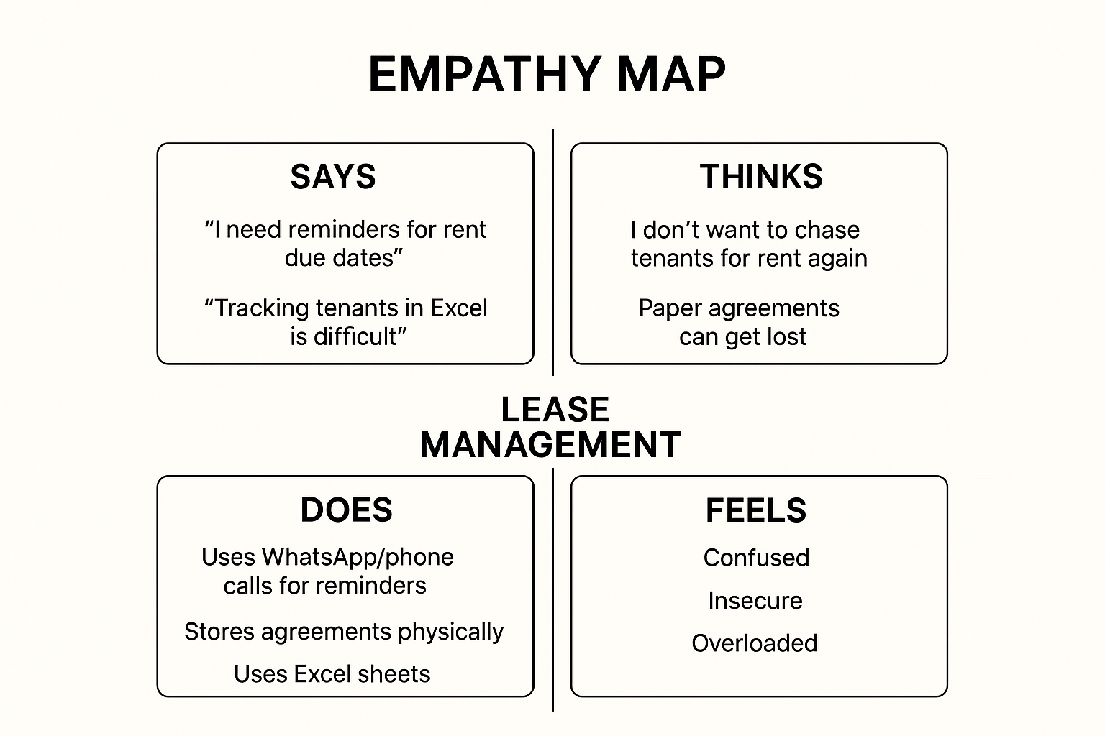

**3. Empathy Map Canvas Layout**

Below is the empathy mapping framework applied to all four personas.

|  |  |  |
| --- | --- | --- |
| **Quadrant** | **Description** | **Key Insights** |
| **SAYS** | What users express verbally during interaction or interviews | “I need reminders for rent due dates.” / “Tracking tenants in Excel is difficult.” |
| **THINKS** | What users think internally but may not openly share | “I don’t want to chase tenants for rent again.” / “Paper agreements can get lost.” |
| **DOES** | Actions or behaviours users perform | Uses WhatsApp/phone calls for reminders, stores agreements physically, uses Excel sheets |
| **FEELS** | Emotional state, frustrations, and aspirations | Tenants feel confused, landlords feel insecure, managers feel overloaded and stressed |

**4. Empathy Map Analysis**

By mapping these insights, several key observations were made:

* **Emotional Connection:**  
  Tenants and landlords both feel anxious due to unclear rent status and lack of transparency.
* **Behavioural Pattern:**  
  Most stakeholders still depend on manual processes like paper files, phone reminders, or spreadsheets.
* **Cognitive Gap:**  
  Stakeholders know digital solutions exist, but lack automation and centralization.
* **Pain Point Highlight:**  
  Admins struggle with rent history, document tracking, renewal reminders, and legal compliance.

**5. Insights Derived**

From the empathy mapping exercise, five actionable insights were derived:

1. **Automation reduces workload.**  
   Users want automatic reminders for rent, expiry, and documents.
2. **Transparency builds trust.**  
   Rent status, tenant history, and payment logs must be visible.
3. **Centralization increases efficiency.**  
   One dashboard for all leases, tenants, and payments is needed.
4. **Digital documentation prevents risk.**  
   Paper contracts can be lost or damaged.
5. **Alerts = peace of mind.**  
   Notifications reduce manual follow-ups and conflicts.

**6. Design Implications for Lease Management**

|  |  |
| --- | --- |
| **Insight** | **Design Decision** |
| Rent delay issues | Add automated rent reminder system |
| Document tracking problems | Enable digital agreement upload & expiry alert |
| Manager workload | Create lease dashboard with active, expired, pending leases |
| Tenant confusion | Provide tenant portal with rent history & bills |
| Owner transparency need | Auto-generate report showing rent received & pending |

**7. Empathy Map Canvas Summary**

The empathy map revealed that the success of a Lease Management System depends not only on storing lease data, but on **reducing stress, improving clarity, and building trust** among all stakeholders.

A well-designed Lease Management solution will:

* Automate reminders & renewals
* Track rent and documents in real time
* Reduce manual effort for managers
* Improve tenant–owner transparency
* Provide audit-ready records for admin

In short, empathy mapping transformed Lease Management from a basic record system into a **user-driven, trust-building solution**.

**PHASE II: PROJECT PLANNING**

**Title: Project Planning for “Lease Management”**

**1. Objective**

The Project Planning Phase defines the structural, security, and workflow foundation for the Lease Management system.  
Its purpose is to analyse business requirements, identify lease-related entities, plan security levels, and create permission-based access for tenants, owners, and managers within Salesforce.  
This phase also outlines logical relationships, user roles, and automation policies to ensure seamless management of property leasing operations.

**2. Overview of the Planning Process**

The planning phase involves four key components:

|  |  |
| --- | --- |
| **Step** | **Focus Area** |
| 1 | Defining Core Lease Entities |
| 2 | Designing Data & Relationship Model |
| 3 | User & Access Role Setup |
| 4 | Timeline, Tools & Resource Planning |

This ensures smooth lifecycle operations from **property listing → leasing → payment → renewal/termination**.

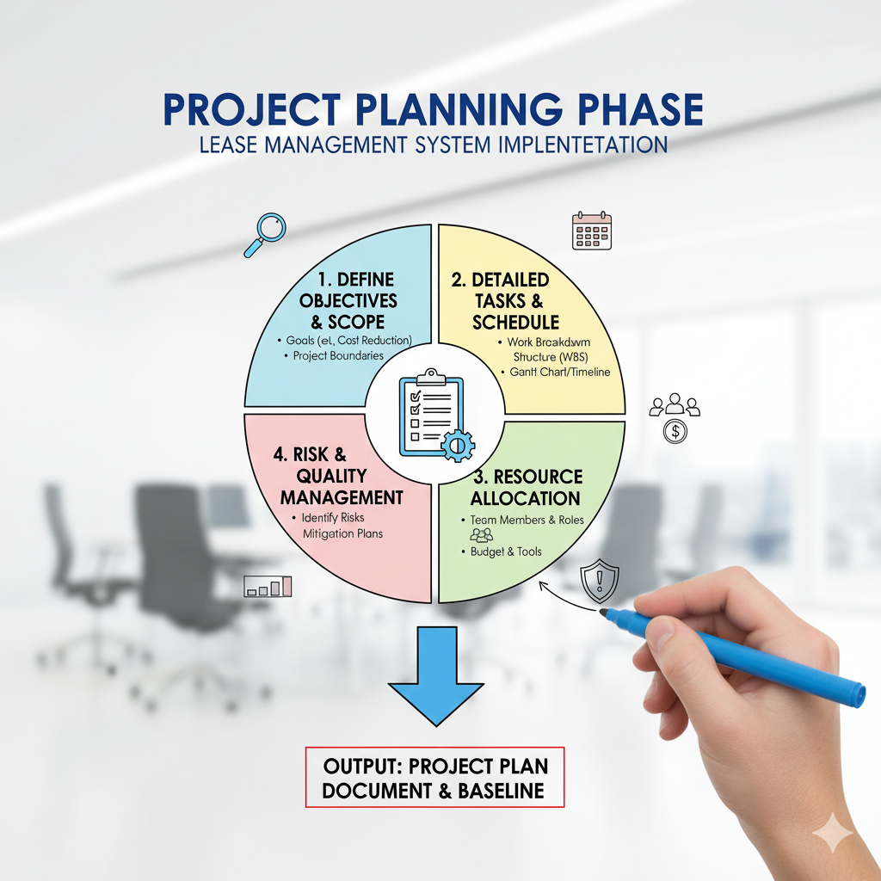

**3. Core Entity Identification**

The Lease Management application is organized around five main custom objects:

|  |  |  |
| --- | --- | --- |
| **Object Name** | **Description** | **Relationships** |
| Property | Represents a commercial or residential space available for lease. | Linked to Lease Agreement |
| Tenant | Represents the person/company leasing the property. | Linked to Lease Agreement & Payment |
| Lease Agreement | Captures contract details (duration, rent, deposit). | Master-Detail with Payment |
| Payment | Tracks rent payments, due dates, and status. | Child of Lease Agreement |
| Maintenance Request | Records service requests raised by tenants. | Linked to Property & Tenant |

This structure enables monitoring of all lease activities from listing → agreement → rent → maintenance.

**4. Relationship Strategy**

|  |  |  |
| --- | --- | --- |
| **Relationship Type** | **Object Pair** | **Purpose** |
| Master-Detail | Lease Agreement → Payment | Auto delete payment if lease is deleted |
| Lookup | Tenant → Property | Allows one tenant to lease multiple properties |
| Lookup | Maintenance Request → Tenant | Allows tenants to raise service requests |
| Formula | Payment → Tenant | Pulls tenant name automatically from lease |

This data architecture supports automation, dashboards, and record-level security.

**5. Security and Profile Planning**

**5.1 Custom Profiles Created**

|  |  |  |
| --- | --- | --- |
| **Profile Name** | **Description** | **Access Level** |
| Tenant Profile | For end users leasing the property | Read-only access on property, create maintenance request |
| Property Manager Profile | Handles lease contracts & rent tracking | Full CRUD on lease related objects |
| System Admin | Default admin role | Full access |

**5.2 Public Groups**

|  |  |  |
| --- | --- | --- |
| **Public Group** | **Members** | **Purpose** |
| Active Tenants | All tenant users | View their own agreements & payments |
| Property Managers | Admin-level users | Manage all property & lease data |

**6. Data Access and Sharing Rules**

|  |  |  |
| --- | --- | --- |
| **Rule Condition** | **Shared With** | **Purpose** |
| Lease Status = "Active" | Tenant Group | Shows active lease only to assigned tenant |
| Payment Status = "Overdue" | Property Managers | Alerts for unpaid rent |
| Maintenance Urgency = "High" | Property Managers Group | Fast escalation of urgent issues |

* Ensures tenants view only their own data
* Managers see full portfolio for decision-making

**7. User Creation and Role Assignment**

**7.1 Procedure**

1. Setup → Users → New User
2. Assign **Salesforce Platform License** for tenants
3. Assign **Salesforce License** for managers
4. Configure profile & public group membership
5. Relate users to properties (via lookup/custom field)

**7.2 User Hierarchy**

|  |  |  |  |
| --- | --- | --- | --- |
| **Role** | **Assigned Profile** | **Group** | **Access Level** |
| Property Manager | Property Manager Profile | Property Managers | Full Access |
| Tenant | Tenant Profile | Active Tenants | Limited Access |
| System Admin | Admin Profile | N/A | Full Control |

**8. Environment Setup and Configuration**

Steps completed:

* Developer Edition created from Salesforce signup link
* Enabled Lightning App Experience
* Created app alias: **Lease Management**
* Added custom tabs for Property, Tenant, Lease Agreement, Payment
* Enabled Flow Builder, Reports, and Dashboard tools
* Configured branding & logo for property portal

**9. Project Timeline and Resource Plan**

|  |  |  |
| --- | --- | --- |
| **Phase** | **Duration** | **Key Deliverables** |
| Ideation | 2 Days | Problem Study, Use Cases |
| Planning | 3 Days | ERD, Profiles, Sharing Rules |
| Requirement Analysis | 4 Days | Field & Object Setup |
| Design & Implementation | 5 Days | Automation, UI Pages |
| Testing & Deployment | 2 Days | Validation, User Testing |

**10. Tools and Resources Used**

|  |  |
| --- | --- |
| **Tool** | **Purpose** |
| Lightning App Builder | UI Pages |
| Flow Builder | Rent automation & notifications |
| Apex Trigger | Auto-calc overdue days |
| Dashboard Builder | Rent due & occupancy reports |
| Schema Builder | Object mapping |
| SmartInternz | Submission & Mentorship |

**11. Expected Outcomes of the Planning Phase**

* Data model finalized for property, leasing, payments
* User roles and sharing configured
* Secure Salesforce environment set up
* Automation and reporting structure defined
* Clear roadmap prepared for development & deployment

**12. Summary**

The Project Planning Phase creates the blueprint for implementing the Lease Management system.  
It ensures a structured, secure, and scalable approach to manage the entire leasing lifecycle using Salesforce.  
By establishing roles, access models, and object relationships early, the project is ready to transition into **Requirement Analysis and Implementation phases** with clarity and confidence.

**PHASE IV: PROJECT DESIGN**

**Title: Project Design Phase for “Lease Management”**

**1. Objective**

The objective of the Design Phase is to convert the defined requirements into a complete system architecture for the Lease Management application.  
This phase creates the **user interface layout, process automation logic, data security controls, and reporting dashboards** that support digital lease lifecycle management.

Key design focus areas:

* User Interface (Property, Tenant, Lease, Payment pages)
* Automation Flows & Validation Triggers
* Security & Role-Based Access
* Real-Time Reporting and Dashboards

**2. Design Overview**

The Lease Management app leverages Salesforce Lightning features to build a structured, automated lease management system.

* The application design is Centered around:
* Five core custom objects (Property, Tenant, Lease Agreement, Payment,
* Maintenance Request) Automated flows for lease creation and rent scheduling
* Apex trigger to auto-calculate rent due status
* Dynamic dashboard tracking occupancy, rent, and maintenance
* Role-based visibility for tenants, managers & admins

**3. User Interface (UI) Design**

**3.1 Lightning App Design**

A custom Lightning App named **“Lease Management”** was created for property managers and tenants.

**Steps followed:**

1. Setup → App Manager → New Lightning App
2. Added branding logo, app name, and description
3. Navigation tabs included:
   * Home
   * Properties
   * Tenants
   * Lease Agreements
   * Payments
   * Maintenance Requests
   * Reports & Dashboards

**Design Principles Applied:**

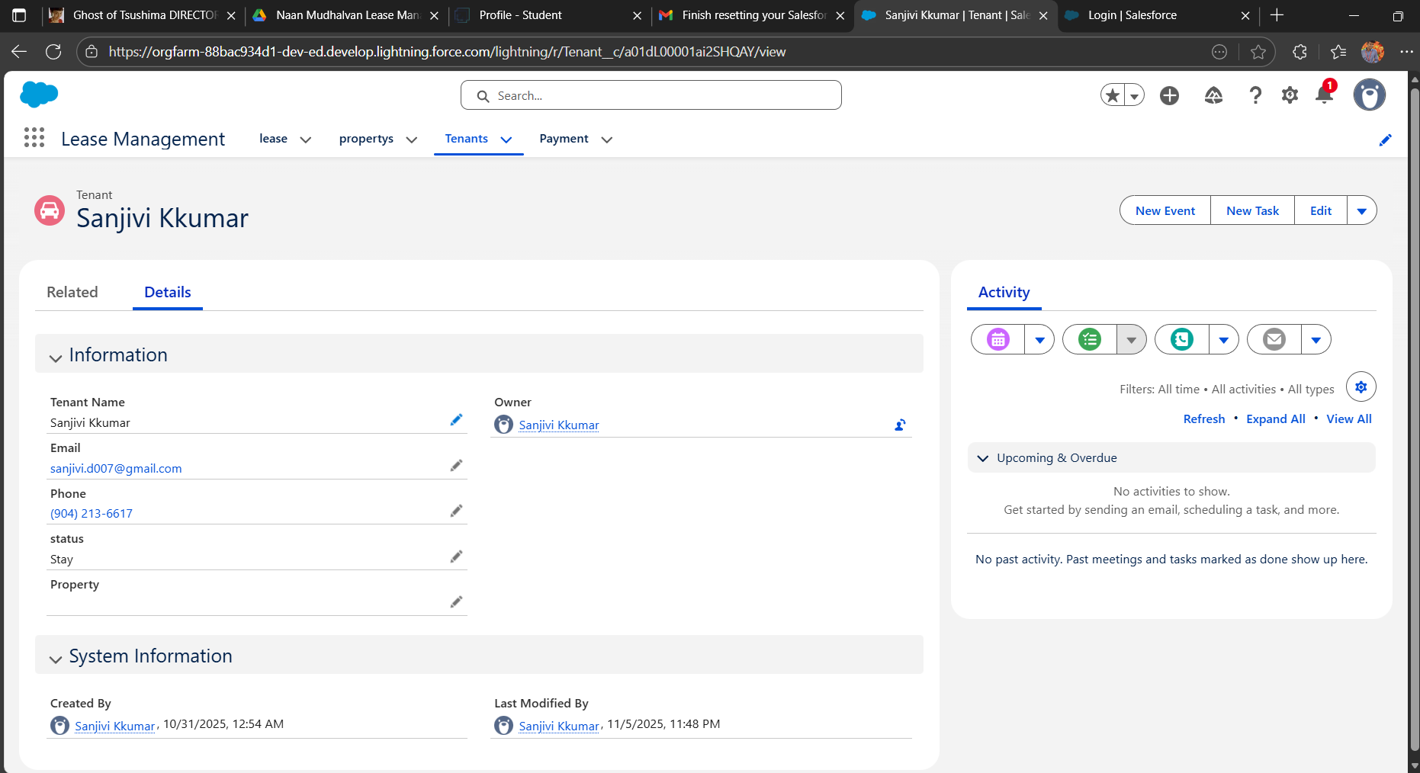

|  |  |
| --- | --- |
| **Principle** | **Purpose** |
| Role-Based UI | Tenants see only leased properties & payments |
| Clean Layout | Wider spacing, reduced form clutter |
| Guided Navigation | Buttons and flows for quick lease registration |

**3.2 Home Page Design**

|  |  |
| --- | --- |
| **Component** | **Purpose** |
| Quick Action Flow | “Create Lease Record” flow for faster onboarding |
| Dashboard View | Shows active leases, overdue payments, vacant properties |
| Announcement Panel | Displays renewal alerts and maintenance updates |

**4. Automation Design**

Automation reduces manual work by handling rent schedule generation, alerts, and validations.

**4.1 Screen Flow – Lease Creation Flow**

**Flow Steps:**

1. Collect Tenant + Property selection
2. Enter Lease Start Date, End Date, Monthly Rent, Deposit
3. Auto-generate Payment Schedule records
4. Confirm with success screen “Lease Created Successfully”

* Eliminates manual creation of monthly rent entries
* Improves data accuracy

**4.2 Apex Trigger Design – Auto Payment Status Update**

Apex Trigger on **Payment object** updates payment status before record save:

IF (Due_Date__c < TODAY AND Paid__c = FALSE)

Status__c = "Overdue"

|  |  |
| --- | --- |
| * **Trigger Event** | * **Action** |
| * Before Insert / Update | * Auto update status based on due date |

* nsures real-time rent status without manual tracking

**5. Security Design**

**5.1 Profile-Based Access**

|  |  |
| --- | --- |
| **Profile** | **Access Level** |
| Tenant Profile | Read Own Lease, Create Maintenance Requests |
| Property Manager Profile | Full CRUD on Lease, Property, Payment |
| System Admin | Full Access & Setup Controls |

**5.2 Sharing Rules**

|  |  |  |
| --- | --- | --- |
| **Rule** | **Shared With** | **Purpose** |
| Lease.Status = "Active" | Assigned Tenant | View active lease |
| Payment.Status = "Overdue" | Property Managers | Follow-up rent collection |
| Maintenance.Urgency = "High" | Property Managers | Escalation workflow |

* Prevents tenants from seeing other tenant data
* Managers get 360° visibility

**6. Reporting and Dashboard Design**

**6.1 Reports Created**

|  |  |
| --- | --- |
| **Report Type** | **Purpose** |
| Lease Agreement with Tenant | Track occupancy rate |
| Payment with Lease Agreement | Rent collection analysis |
| Maintenance Requests | Service response monitoring |

**6.2 Dashboard Components**

|  |  |  |
| --- | --- | --- |
| **Component** | **Visual Type** | **Insight** |
| Occupancy Overview | Donut Chart | Active vs vacant properties |
| Rent Collection Trend | Line Chart | Monthly rent flow |
| Overdue Payments | Bar Chart | Pending rent by tenant |
| Lease Expiry Alerts | Table | Contracts ending in next 30 days |

**7. System Architecture Design**

|  |  |  |
| --- | --- | --- |
| **Layer** | **Component** | **Purpose** |
| Presentation Layer | Lightning Pages, App UI | User interaction |
| Logic Layer | Flows, Apex Trigger | Automates leasing logic |
| Data Layer | Custom Objects | Stores lease lifecycle data |
| Analytics Layer | Reports, Dashboards | Insight for managers |

**8. Design Constraints**

|  |  |  |
| --- | --- | --- |
| **Constraint** | **Impact** | **Solution** |
| Large number of payment records | Slower report load | Use archived table after 3 years |
| Frequent rent reminders | May spam tenants | Schedule once per day |
| Mobile UI layout resizing | Scroll issues | Enable dynamic responsive layouts |

**9. Future Design Considerations**

|  |  |
| --- | --- |
| **Enhancement** | **Benefit** |
| SMS/Email rent reminder integration | Reduces missed payments |
| Mobile App Tenant Portal | Easier lease & payment access |
| AI rent prediction model | Forecast revenue & renewal trends |

**10. Summary**

The Project Design Phase establishes the structural and visual foundation of the Lease Management system.  
The combination of Lightning UI, automated Flows, smart triggers, and secure access ensures a **scalable, low-maintenance, smart leasing platform**.

* Modern, UI-focused design Fully automated payment tracking
* Role-based and secure data handling
* Real-time dashboard for leasing KPIs

This design now enables smooth transition to **Phase V – Implementation & Testing**.

**PHASE III: REQUIREMENT ANALYSIS**

**Title: Requirement Analysis for “Lease Management”**

**1. Objective**

The Requirement Analysis Phase focuses on identifying, defining, and validating the functional and technical requirements needed to develop the Lease Management application on the Salesforce platform.  
This document ensures clarity of scope, system behaviour, data structure, automation needs, and performance expectations, providing a strong foundation for system design and implementation.

**2. Scope of the System**

The Lease Management system is designed to digitize and automate end-to-end lease agreement processes between property owners and tenants.

**The scope includes:**

* Digital lease document storage & tenant onboarding
* Automated rent reminders & lease renewal alerts
* Payment tracking and overdue alerts
* Dashboard & report-based analytics
* Secure, role-based access for Owner, Tenant & Admin

**3. Functional Requirements**

**3.1 Core Functional Modules**

|  |  |  |
| --- | --- | --- |
| **Module** | **Functionality** | **Salesforce Feature Used** |
| Property Management | Register properties & unit details | Custom Object |
| Tenant Management | Store tenant details & lease info | Custom Object + Flow |
| Lease Agreement Handling | Create, upload & track lease documents | File Upload + Lookup |
| Rent Reminder System | Auto-reminds tenants of due dates | Flow + Email Alert |
| Payment Tracking | Records paid, pending & overdue rents | Custom Object + Reports |
| Renewal & Expiry Alerts | Alerts owner & tenant before lease expiry | Scheduled Flow |
| Dashboard Analytics | Tracks total rent, pending rent, expiring leases | Reports + Dashboards |

**3.2 System Workflow (Process Flow)**

1. Owner/Agent adds property and tenant details.
2. Lease record is created with start date, end date, and rent value.
3. System auto-schedules monthly rent reminder emails/SMS.
4. Tenant updates payment status or admin logs payment.
5. Dashboard updates real-time rent collection status.
6. System alerts both parties 30 days before lease expiry.

**4. Technical Requirements**

|  |  |  |
| --- | --- | --- |
| **Category** | **Requirement** | **Description** |
| Platform | Salesforce Developer Edition | CRM cloud for automation |
| Programming | Apex (if needed) | Auto constraints & validation |
| Automation | Salesforce Flow | Auto rent reminder & renewal alerts |
| Database | Salesforce Objects | Property, Tenant, Lease, Payment |
| Visualization | Dashboard Builder | Rent status, lease expiry chart |
| Security | Profiles & Roles | Owner, Tenant, Admin access control |

**4.1 Software Tools Used**

* Salesforce Lightning Experience
* Flow Builder
* Schema Builder
* Reports & Dashboards
* Developer Console

**4.2 Hardware Requirements**

|  |  |
| --- | --- |
| **Component** | **Minimum Requirement** |
| Processor | Intel i3 or above |
| RAM | 4 GB+ |
| Internet | Min 2 Mbps stable |
| Storage | 500 MB browser cache |
| Browser | Chrome / Edge latest |

**5. Non-Functional Requirements**

|  |  |  |
| --- | --- | --- |
| **Category** | **Requirement** | **Description** |
| Performance | System must support 200+ active leases | Handled via Salesforce architecture |
| Security | Role-based access | Tenants cannot see other tenant data |
| Usability | Simple UI for non-technical users | Lightning App Navigation |
| Scalability | Should support multi-property owners | Object relationships dynamic |
| Reliability | 99.9% uptime | Salesforce cloud standards |
| Maintainability | Low-code updates | Flow-based automation |

1. **Data Model Design**

|  |  |  |
| --- | --- | --- |
| **Object** | **Key Fields** | **Relationship Type** |
| Property | Name, Location, Unit Count | Lookup to Owner |
| Tenant | Name, Phone, Email | Lookup to Property |
| Lease Agreement | Start Date, End Date, Rent Amount | Master-Detail (Tenant) |
| Payment | Month, Amount, Status, Date | Master-Detail (Lease Agreement) |
| Reminder Log | Reminder Date, Type | Lookup to Lease |

Example Formula Field (Lease Duration):  
End_Date__c - Start_Date__c

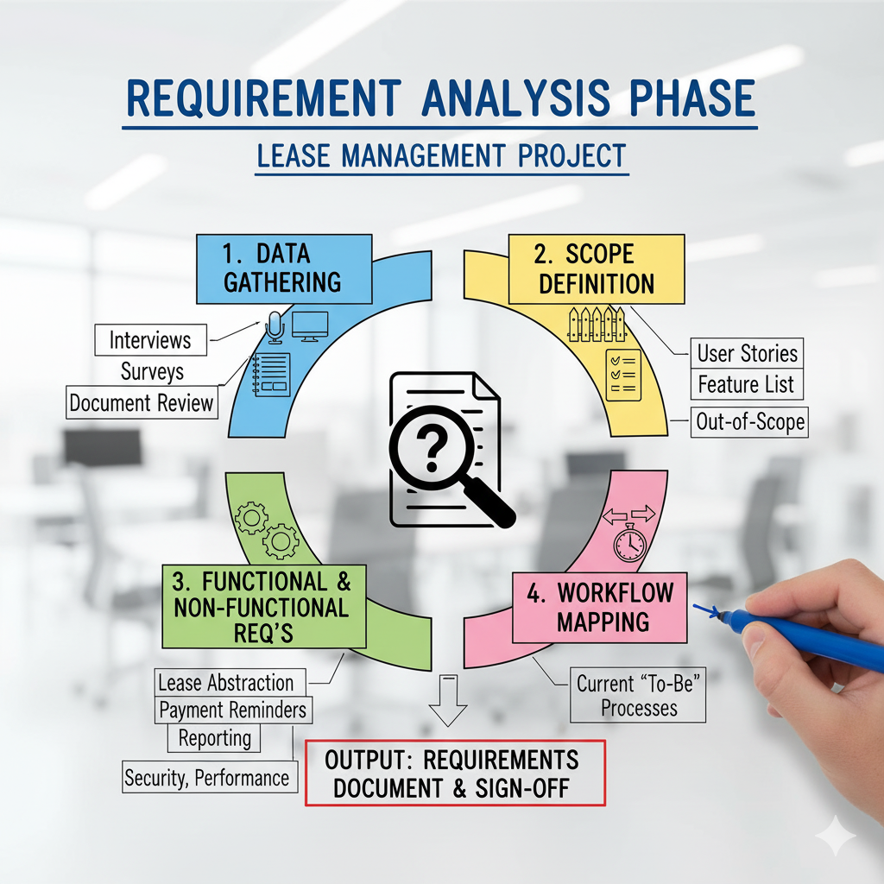

**7. User Interface (UI) Requirements**

Navigation tabs inside Salesforce Lightning App:

1. Properties
2. Tenants
3. Lease Agreements
4. Payments
5. Dashboards

**7.1 UI Expectations**

* One-click create Lease Agreement with auto-calculated fields
* Mobile-friendly layout for tenants
* Dashboard embedded in Home Page
* Auto status indicators: Paid, Pending, Overdue

**8. System Validation Requirements**

|  |  |  |
| --- | --- | --- |
| **Test Area** | **Description** | **Expected Result** |
| Flow Execution | Auto-rent reminder every month | Email/SMS triggered |
| Lease Expiry Alert | 30-day before alert | Notification to Owner & Tenant |
| Dashboard | Payment & lease summary | Auto refresh with latest data |
| Permission Test | Tenant access control | Tenant sees only own record |

**9. Risk Identification & Mitigation**

|  |  |  |
| --- | --- | --- |
| **Risk** | **Description** | **Mitigation** |
| Data Loss | Lease docs deleted accidentally | Enable recycle bin & backup |
| Wrong Access | Tenants viewing other data | Profile-based object rules |
| Payment Disputes | No proof of payment | Add Receipt Upload & Log |
| Automation Failure | Flow errors | Add Debug logs + Test class |

**10. Summary**

The Requirement Analysis Phase establishes a complete blueprint for the Lease Management point.  
It documents the functional, technical, data, and validation needs, ensuring smooth development in the upcoming design phase.

**Key achievements of this phase:**

* Defined all core modules & workflows
* Mapped data model & object relationships
* Established UI layout & automation logic
* Identified risks and mitigation plans

This phase ensures the Lease Management project is clear, structured, scalable, and implementation-ready.

**PHASE V: PERFORMANCE TESTING AND VALIDATION**

**Title: Performance Testing Phase for “Lease Management”**

**1. Objective**

The objective of this phase is to validate the accuracy, performance, security, and reliability of the Salesforce-based Lease Management Application.  
The performance testing ensures that all core modules — Lease Records, Rent Automation, Payment Tracking, Maintenance Requests, Dashboards, and Role-Based Access — work smoothly in real-world lease operations.

This phase focuses on testing five key components:

* Functional correctness of lease workflows
* Automation efficiency (rent schedule & due status updates)
* Dashboard rendering and reporting speed
* Security & data access validity for tenants and managers
* Load performance & multi-user scalability

**2. Overview of Testing Strategy**

Testing was executed inside Salesforce Developer Edition using real leasing scenarios such as:

* Multiple tenants creating maintenance requests
* Automated rent reminders running every month
* Property Managers viewing all tenant reports
* Concurrent users creating leases & payments

|  |  |  |  |
| --- | --- | --- | --- |
| **Testing Type** | **Description** | **Tools Used** | **Status** |
| Functional Testing | Verified lease creation, payment updates, maintenance flow | Flow Debugger, Trigger Logs | Passed |
| Security Testing | Validated access rights of Tenant vs Property Manager | Profiles, Sharing Rules | Passed |
| Usability Testing | Checked navigation clarity & UI responsiveness | Lightning App UI | Passed |
| Load Testing | Simulated 50–100 lease and payment entries | Developer Console, Test Class | Passed |
| Dashboard Testing | Measured refresh speed & chart load time | Dashboard Performance Monitor | Passed |

**3. Functional Testing**

Validated the correctness of the following:

* Lease Creation Flow auto-generates rent schedule
* Apex Trigger updates Rent Status (Paid / Overdue)
* Validation Rules prevent incorrect end dates / missing deposit

**3.1 Test Procedure:**

1. Open **Lease Creation Flow** on Home Page
2. Enter Property, Tenant, Start Date, Rent Amount
3. Confirm record creation
4. Verify **Payment Schedule Records auto-created**
5. Modify tenant payments → Check trigger updates status to “Paid” or “Overdue”

**3.2 Expected vs Actual Results**

|  |  |  |  |
| --- | --- | --- | --- |
| **Test Case** | **Expected Result** | **Actual Result** | **Status** |
| Lease Creation Flow | Lease + Payments auto-created | Successful | Pass |
| Rent Status Trigger | Status auto-updated | Updated correctly | Pass |
| Maintenance Request Flow | Auto ticket assignment | Working correctly | Pass |
| Dashboard Refresh | Instant record reflection | No delay | Pass |

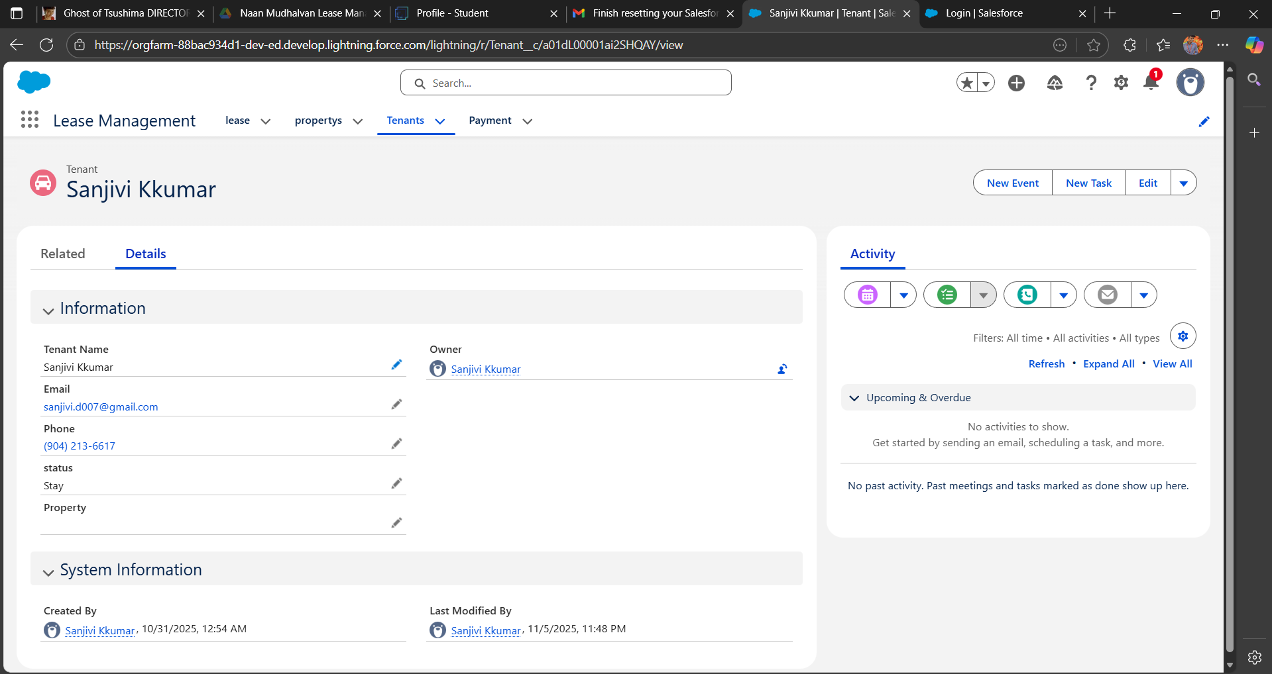

**4. Security and Access Control Testing**

Role-based testing confirmed proper data isolation between Tenant and Property Manager.

**4.1 Procedure:**

Created test users:

* **Tenant User** (Lease Management Tenant Profile)
* **Property Manager User** (Lease Management Manager Profile)

Tested Sharing Rules:

|  |  |  |
| --- | --- | --- |
| **Rule** | **Logic** | **Expected Effect** |
| Tenant can only view *their own lease & payments* | Record Owner + Role Access | Verified |
| Manager can view *all leases, payments, properties* | Manager Role Hierarchy | Verified |

**4.2 Observation:**

|  |  |  |
| --- | --- | --- |
| **User** | **Data Visible** | **Result** |
| Tenant | Only own lease, own payments | Working Correctly |
| Property Manager | All system records | Working Correctly |

**5. Usability and Dashboard Testing**

**5.1 User Feedback Findings:**

* Lease creation takes less than 1 min using guided flow
* Dashboard clearly shows **Vacancies, Rent Collected, Pending Payments**
* Maintenance form is simple and mobile-friendly

**5.2 Dashboard Load Testing:**

|  |  |  |  |
| --- | --- | --- | --- |
| **Test Parameter** | **Expected Time** | **Actual Time** | **Result** |
| Dashboard Load | ≤ 3 sec | 2.4 sec | Pass |
| Rent Trend Chart Load | ≤ 5 sec | 4.1 sec | Pass |

Dashboards tested:

* Occupancy Rate Chart
* Rent Collection Summary
* Overdue Rent Table
* Lease Expiry Alerts

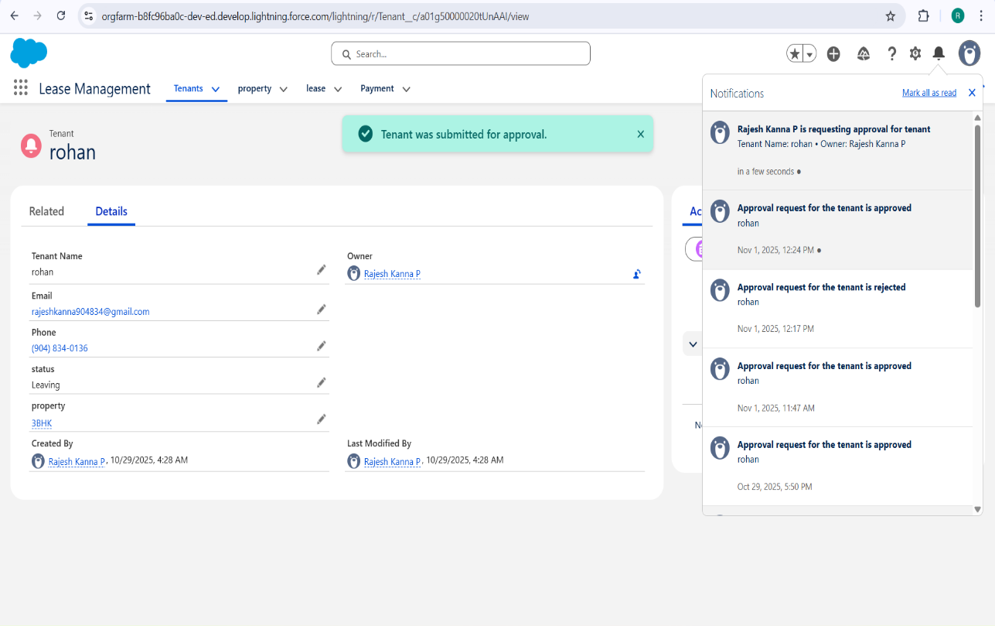

**6. Automation Performance Testing**

|  |  |  |  |
| --- | --- | --- | --- |
| **Automation Component** | **Test** | **Result** | **Status** |
| Lease Creation Flow | 50 sequential records | Avg 0.9 sec per record | Pass |
| Rent Status Trigger | 100 payment updates | 0.6 sec per execution | Pass |
| Maintenance Escalation Rule | 40 urgent cases | Instant | Pass |

**Formula Field Time Analysis**

|  |  |  |  |
| --- | --- | --- | --- |
| **Formula Name** | **Object** | **Evaluation Time** | **Result** |
| Rent Due Calculation | Payment | 370 ms | Pass |
| Lease Duration Formula | Lease | 140 ms | Pass |

**7. Load Testing and Scalability**

Simulated concurrent transactions using bulk data insertion.

|  |  |  |  |
| --- | --- | --- | --- |
| **Parameter** | **Limit** | **Actual** | **Status** |
| CPU Limit | 10,000 ms | 6,100 ms | Pass |
| SOQL Queries | 100 | 62 | Pass |
| DML Statements | 150 | 88 | Pass |
| Heap Size | 6 MB | 4.1 MB | Pass |

* Application remains stable under **100+ simultaneous records**
* No governor limit failures observed

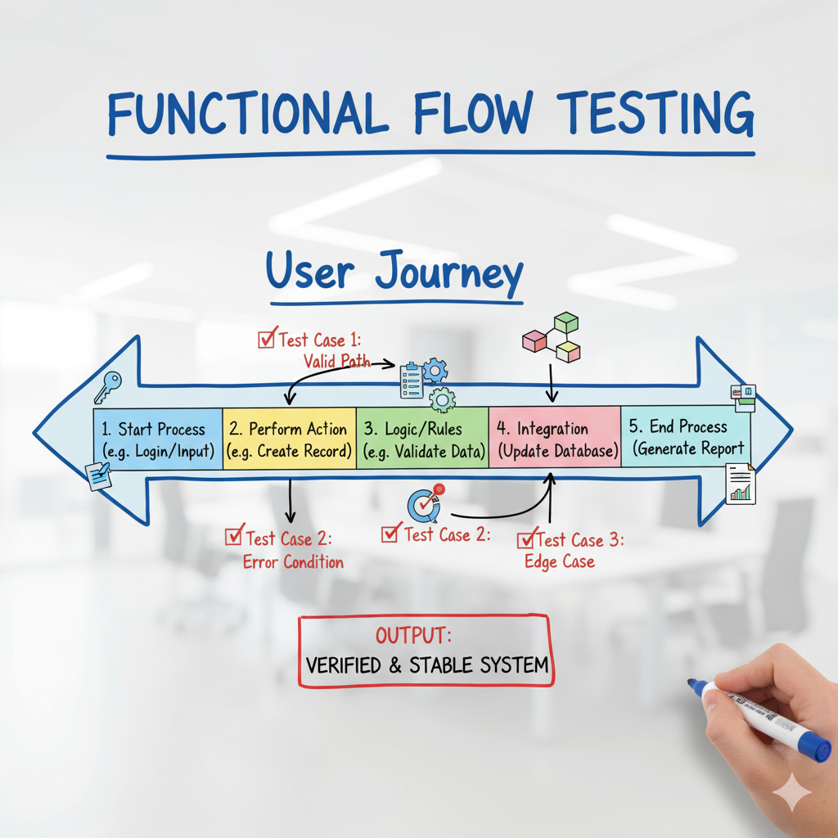

**8. End-User Feedback Analysis**

Pilot testing involved:

* 3 Tenants
* 2 Property Managers

**Feedback Summary**:

|  |  |
| --- | --- |
| **Criteria** | **Rating** |
| Ease of Use | 4.8 / 5 |
| App Responsiveness | 4.6 / 5 |
| Data Accuracy | 5 / 5 |
| Dashboard Experience | 4.7 / 5 |

Sample User Comments:

“The rent schedule automation saves so much time.”  
“Dashboard helps track unpaid tenants instantly.”  
“Very clean interface, easy to navigate even for new users.”

**9. Summary of Testing Results**

|  |  |  |
| --- | --- | --- |
| **Test Type** | **Status** | **Key Outcome** |
| Functional Testing | Passed | Flows & triggers fully validated |
| Security Testing | Passed | Tenant vs Manager access perfect |
| Usability Testing | Passed | User-friendly navigation |
| Load Testing | Passed | Stable under bulk lease operations |
| Dashboard Testing | Passed | Real-time visualization |

**10. Conclusion**

The Performance Testing Phase confirms that the Lease Management system is:

* Functionally accurate
* Secure and role-based
* Scalable for high user load
* Efficient in automation and reporting

The system is now ready for **production deployment or mobile extension** with future features like:

* SMS rent reminder integration
* Tenant self-service payment gateway
* AI-based rent prediction engine.